Liza’s First Spelling Bee

Liza has loved words for as long as she can remember. She loves the sounds words make, the shapes of words, and the way letters are arranged in words. Some of her favorite words are lollipop, balloon and purple. When Liza has free time at school, she likes to write down words and doodle on the letters to create fun drawings.

Sometimes she takes the drawings home to her parents, and sometimes her teacher pins them to the classroom bulletin board.

One day, Liza’s art teacher, Mr. Jordan, walked into her classroom and noticed one of Liza’s recent pieces of word art. He was very impressed with her creativity and her word choice. After all, not many fourth graders know the word sanctuary and how to spell it, let alone know what it means.

Liza’s word art turned the word sanctuary into a beautiful image with birds, rabbits and butterflies in a natural, undisturbed setting with trees and a pond.

Mr. Jordan waited until the class went to recess, and then talked to Liza’s teacher, Mrs. Roberts, about Liza’s talent. Mrs. Roberts said, “She is a very good artist, and she is also quite talented at spelling.”

“I’m sure the fact that she turns the letters of words into characters and images to form her artistic pieces helps her remember the spellings. She could do very well in a spelling bee, and her doodling would help her study,” said Mr. Jordan. “I could help her too by creating word art with her,” he added.

“That’s a great idea. I will ask Liza if she is interested in entering the spelling bee,” Mrs. Roberts replied. “It is only three weeks away, so she would have to study pretty hard,” she added.

Later that day Mrs. Roberts asked Liza if she could stay for a couple of minutes after class dismissal. Liza asked Mrs. Roberts if she was in trouble, and Mrs. Roberts replied, “Quite the contrary.”

Liza was still nervous, but she stayed to see what her teacher wanted. When Liza found out Mrs. Roberts wanted her to enter the spelling bee, she was thrilled and honored. Usually only fifth graders enter the spelling bee. Liza was even more excited when she heard that Mr. Jordan was going to help her study with the use of art.

Liza and Mr. Jordan met every day after school for the next three weeks. Mrs. Roberts had given them word lists to study. Liza studied hard by turning each word into a drawing. When she wasn’t sure

what a word meant, Mr. Jordan would tell her and help her come up with an idea for the word art.

When the big day arrived, Liza felt well prepared, but she was still nervous.

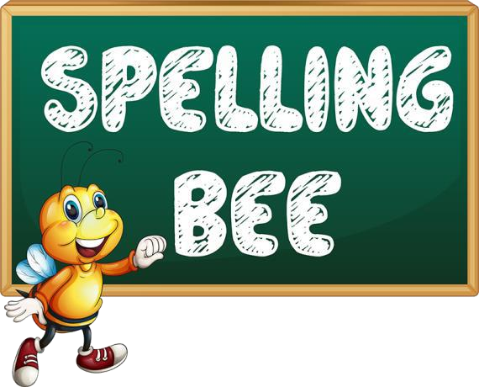There were 26 fifth graders and 3 fourth graders in the spelling bee.

After the first three rounds, there were still 21 contestants; Liza was one of them. Liza was holding her own and continued to successfully spell difficult words including economy, avenue, tissue and station over the next several rounds. She knew her word art was helping her succeed because she could visualize the words.

After six more rounds, there were only three contestants remaining – Liza and two fifth graders.

It was Liza’s turn to spell. Her word was migration. She remembered drawing flying ducks for the word. She pictured her art, and spelled the word correctly. One of the fifth graders wasn’t so lucky during this round, and it was now down to Liza and one other contestant, a boy named Ben.

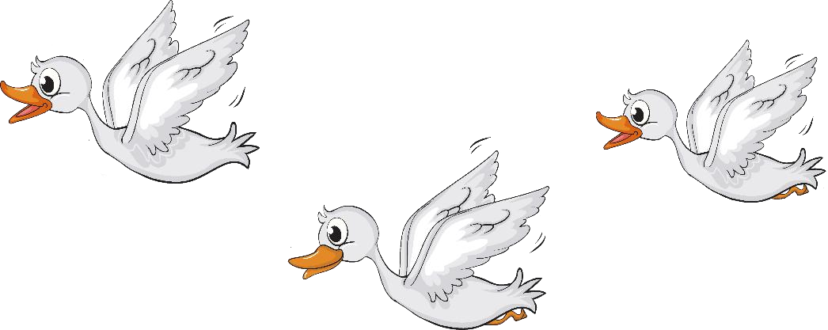

Ben went first in this round. He was given a word that Liza knew very well, valley. Ben knew the word too and spelled it without a hitch.

Now Liza had to spell her word correctly to stay in the bee; otherwise, Ben would win. She listened carefully as her word was announced. The word sounded familiar, but it wasn’t one of the words she had studied. The word was tolerable. Liza thought about words that contained similar sounds. She knew how to spell tolerate and notable. She did, and it worked. Liza made it to the next round.

Ben listened to his next word and hesitated for quite a while. He took his time and eventually spelled ceremony correctly.

Liza’s next word was deception. This too was a word she had not studied. She thought and thought about the word and listened to the sounds, but in the end, she was one letter off in her spelling. Liza was slightly sad she didn’t win, but at the same time she was proud of herself for making i t this far in her first spelling bee. Plus, she knew she could come back next year and try again.